**I-40 Bridge Metadata**

The data provided here is in the form of Excel sheets, and animation files as listed in Table 1. Each sheet represents the acceleration data for different case studies in this research. The first dataset provided is for the undamaged case and can be treated as healthy data, then acceleration data for each damage case is provided as per their severity viz. E1, E2, and E3.

Table1: List of data provided

|  |  |  |  |
| --- | --- | --- | --- |
| S. No. | Acceleration Dataset | AVI representation obtained from FEM analysis | |
| Deflection | Stresses |
| 1. | S1.xlsx | D1.avi | M1.avi |
| 2. | S2.xlsx | D2.avi | M2.avi |
| 3. | S3.xlsx | D3.avi | M3.avi |

Animation for Stresses

Animation for Deflection

Acceleration Data

  

One way – two vehicle case

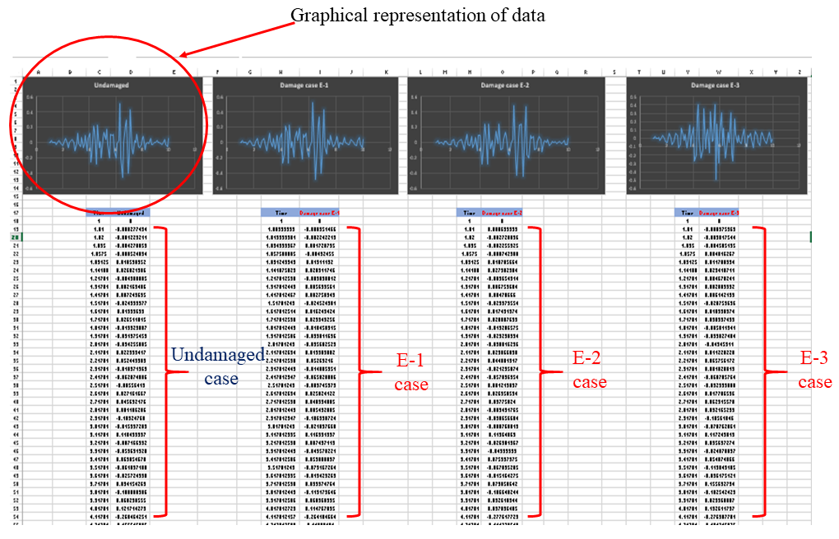The provided Excel spreadsheet ‘S1.xlsx’ contains acceleration data of one-way traffic conditions for two vehicle loads. It encompasses four distinct datasets corresponding to various case studies, viz. undamaged, and damaged cases E1, E2, and E3. Additionally, the acceleration response is visually depicted through graphical representations to facilitate enhanced comprehension as shown in Fig. 1. Similarly, S2 and S3 represent data for ‘two way – two vehicles’ and ‘one way – six vehicles’ respectively.

Fig.1 Data representation

The provided ‘D1.avi’ and ‘M1.avi’ contain animation files generated from FEM analysis for the ‘one way- two vehicles’ condition for deflection and stress respectively. Similarly, other files are for ‘two way – two vehicles’ and ‘one way – six vehicles’ cases as specified for acceleration data.